**Buddy System**

Name : CHIN GUAN XUE

IC No. : 021019080809

Student ID:P22014733

Module Code:4067CEM

Title: SOFTWARE DESIGN

Lecturer: Ms. Nadrah Abdul Hadi

**THE FIRST QUESTION:** Did you have any difficulties in making friends?

The first question in my survey “Did you have any difficulties in making friends” is used to point out the most biggest problem in this 5G network world , which is making real life buddy / friend . Based on the diagram below , which show the data from my surveys , 3 users state that they are still good in making friends , followed by two users who are really hard to make friends . In the data , we can know that there is more users are quite hard in making friends.

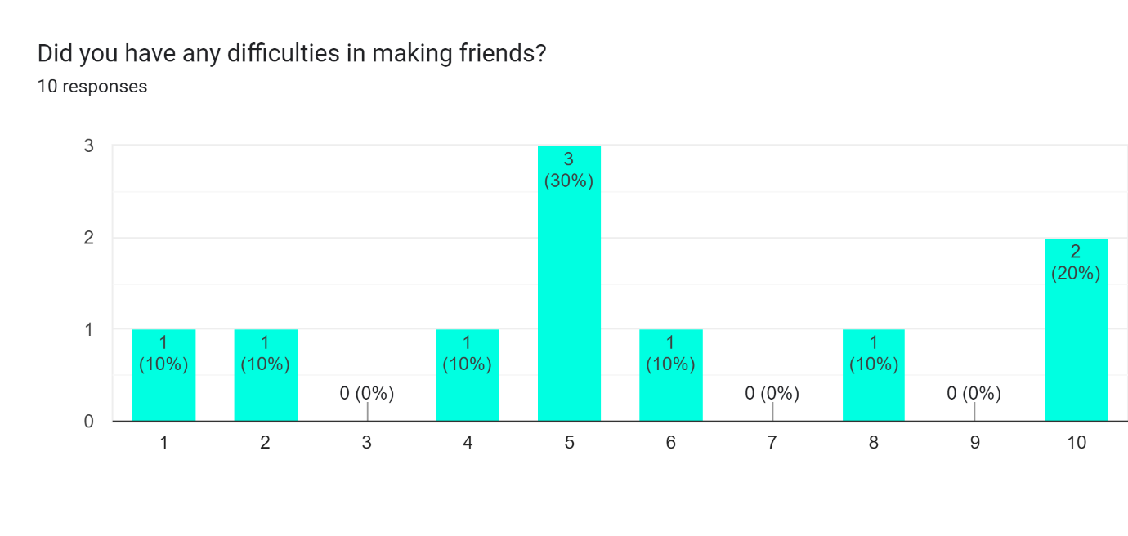

**THE SECOND QUESTION:HOW LONG IT TAKE FOR YOU TO MAKE A NEW FRIEND IN NEW ENVIRONMENT?**

The second question is used to further enhance the first question on the problem that nowadays people are hard to find friends in reality world . In this survey , users takes a little longer time to make new friends but somehow 4 of them need a longer time to find a buddy in a new environment . This also can show that why this system need to be developed .

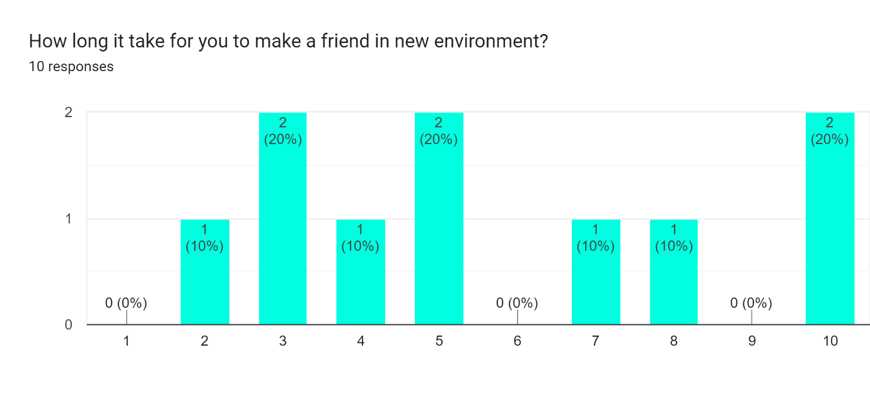

**THE THIRD QUESTION : DID YOU THINK THIS SYSTEM CAN HELP YOU IN MAKING FRIENDS?**

In this survey , 70 % of users think that this system is able to help them to make friends in INTI International College Penang .There is still 20% of users did not trust that this application can help them to make friends in real life. 10 % of them still hesitate that this application maybe can help them to make friends .

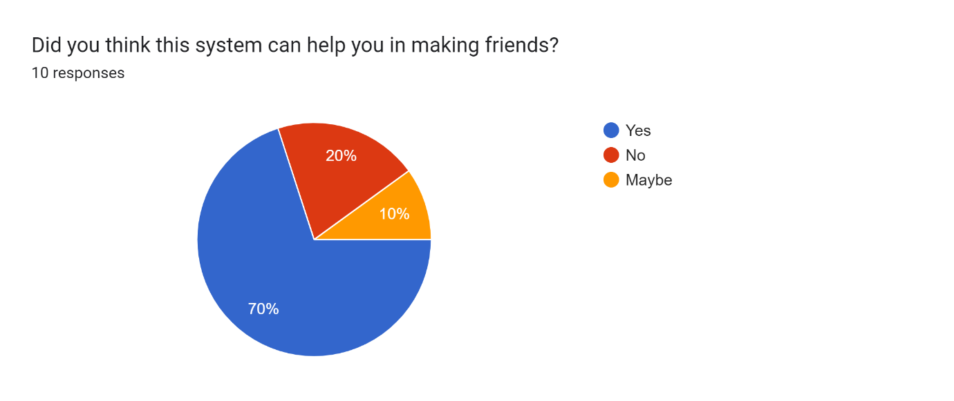

**THE FOURTH QUESTION: WHICH INFORMATION YOU WOULD LIKE TO KNOW WHEN YOU ARE MAKING BUDDIES ONLINE ?**

In order to help user to know more about each other , knowing their normal beings is one of the best ways to get close with them . 60% of the users picked hobby as the information that they wanted to know about each other . This is because person with same hobby are more likely to get to know each other . As an example , users who often swim can easily get to know each other by exchanging their technique to swim .20% of users want to know all information of another users to have more topics when come to the communication part . 10 % of them chose to know about the place another user used to go and 10% of the user want to know about the latest assignment information so that they can share their mind or even form a group[ to complete the assignment together.

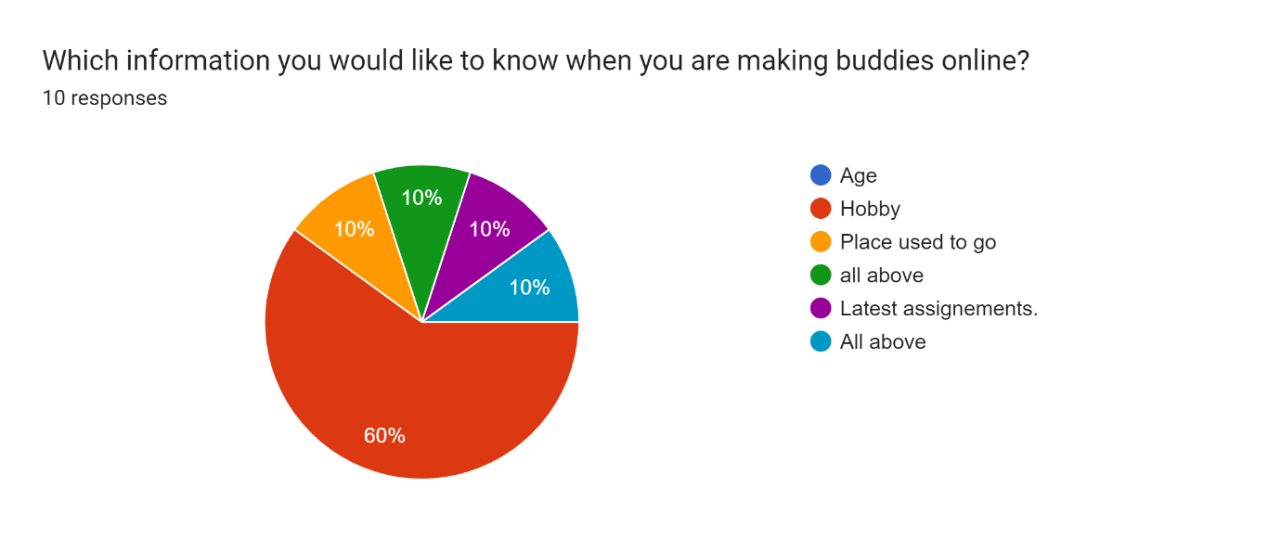

**THE FIFTH QUESTION:IF THIS SYSTEM IS DEVELOPED , WOULD YOU TRY TO USE IT TO MAKE FRIENDS OR BUDDIES?**

“Never try never know ” , is a phrase that we always heard when come to a new thing . All the users that completed this survey give a perfect example for this old phrase . Everyone are having the passion to use this new system to make friends or buddy in IICP.

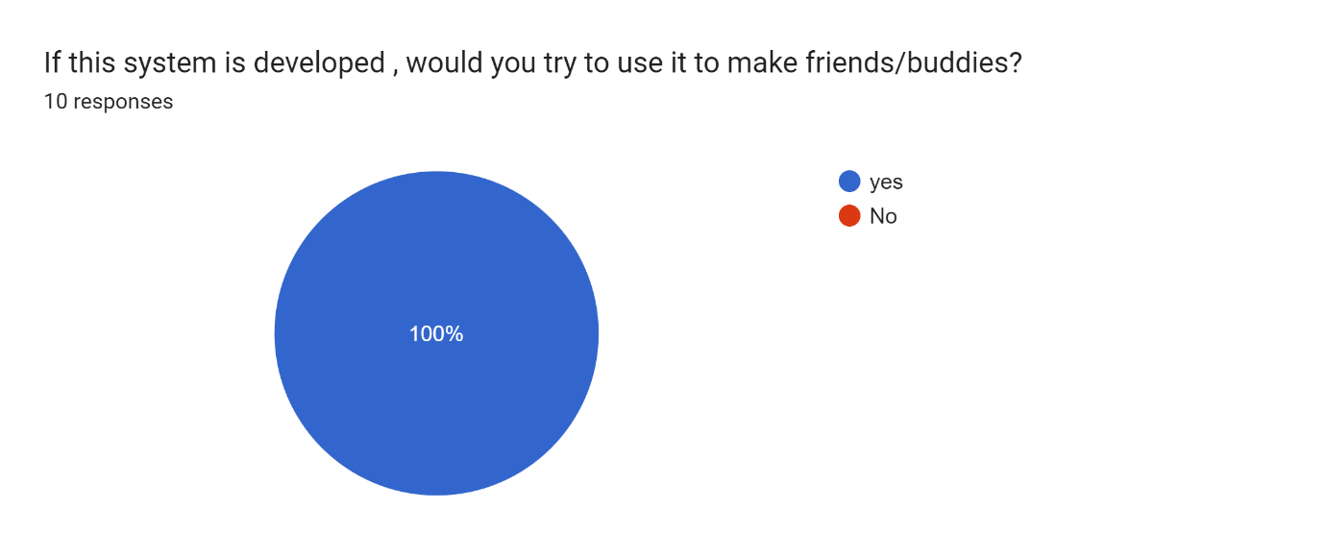

**THE SIXTH QUESTION:IF THE SYSTEM IS GOING TO OPEN FOR ALL OUTSIDERS TO USED , WOULD YOU SUPPORT THIS SYSTEM?**

A good application could not just limited at one place . A good buddy system also . In order to prevent people not to know each other in future world , a buddy system should be developed so that they are able to get to know friends and carry out some outdoor activities or even some online game events.

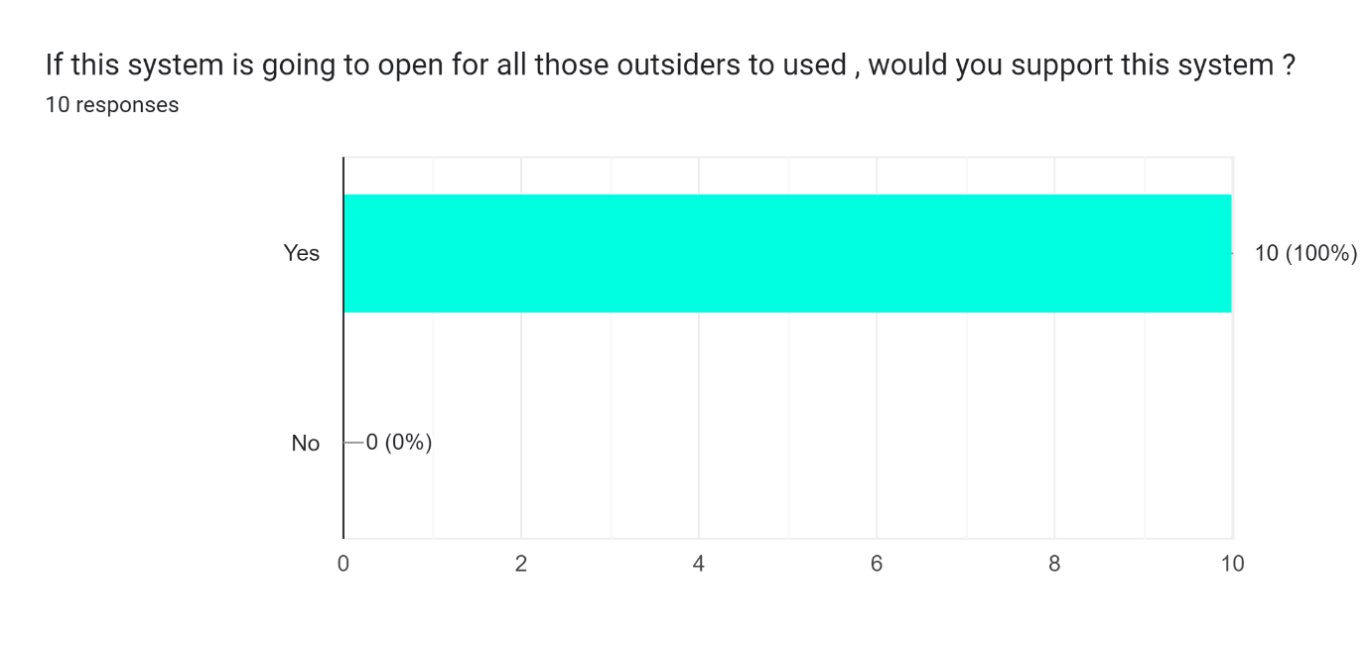

**To further enhance our buddy system , question about the features also being asked inside the survey I did . Below are the answer and the reason that I choose from 10 users.**

Firstly , users wanted to have minigames in this application .Not only one user required to have a minigame . This is because users find out that it not only can help user to have same topics to start the communication , it also can help users to enhance their relationship when they are playing the same minigames with each other . Some multiplayers minigames should be added into the application so that they can make friend much more easier and also can help to maintain the relationship with each other.

Besides , picture of user and image viewer are also requested to be added into the application . After a long time that we survive with virus , putting on a mask became a very common things that people do . So , in order to recognise each other after few years , having a picture viewer can helps a lot when they met offline so that they can recognise each other .

On the other hand , a beautiful login pages and a user friendly home UI page is the most important thing in developing an application . This not only can attract more users to use the application that had been developed , it can also help user to handle the application easily . This also related to another feature that gave by another user which is the language used inside the application must be easy to understand and also more familiar language need to be applied to the application to prevent the user get into a bug or error .

Next is about the communication system . A communication feature need to be added inside the application to prevent user need to use other platform to communicate with each other . One of user decide to add a forum discussion feature inside so that user can join different forums to find friends with the same topic so that hey have more things to communicate in the future time .

Last but not least is about the auto-finding system , system algorithms must be able to find out users’ like so that system can recommend friends with the same tags .